Press Release

BUILD/11/2024/348 Date: 28 November 2024

Attn: News Editor/ Chief Reporter/ Assignment Editor /Business Page-in-Charge:

**Title: Business Initiative Leading Development (BUILD) Signs MoU with Southeast University**

Business Initiative Leading Development (BUILD) Signs an MoU with Southeast University (SEU) on Wednesday, November 27, 2024, at the office of their Career and Professional Development Service (CPDS).

The MOU is to foster a professional network to develop and promote academic and education relationships through research, internship, professional exchanges, and policy advocacy between the two organizations. It will facilitate research and public-private dialogue (PPD) to create a transparent, conducive business environment in Bangladesh. On behalf of BUILD, Ferdaus Ara Begum, CEO, BUILD and from SEU, Mohammad Nazmuddoza, Director, CPDS signed the MOU.

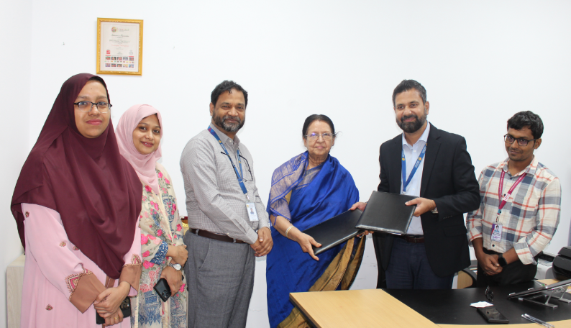This joint initiative will be aimed at conducting research activities and exchanging information including academic and policy research that will facilitate trade simplification and business improvement along with organizing joint seminars, and research programs to bolster the industry-academia collaboration in Bangladesh. Dr Abul Hasanat Alamgir, Professor and Director, Institute of Research and Training (IRT), SEU, and from BUILD Pallab Bhattacharja, Additional Research Director, Kanis Fatama, Sr Research Associate, Rawshon Shahriar, Sr Research Associate were present at the event. The signing ended with a tour of each department, library and other infrastructural support areas of the reputed University.