Press Release

BUILD/05/2025/194 Date: May 21, 2025

Attn: News Editor/ Chief Reporter/ Assignment Editor /Business Page-in-Charge

Title: Pre-Budget Round Table on Tax Implications for Industries

BIDA and BUILD jointly organized a Pre-Budget Round Table on 20th may, 2025 at the BEZA conference room, bringing government officials, private sector representatives, and key stakeholders together to discuss pressing tax issues ahead of the upcoming national budget FY 2025-26. A major concern echoed throughout the discussion was the Minimum Tax policy — particularly its impact on struggling or low-margin businesses.

The meeting opined that if a business is making a loss, it is liable to pay tax on yearly turnover, which is mentioned in Income Tax Act 2023 Section 163. In most cases, tax is paid from working capital, which is hampering existing and potential investment, though there is a tax holiday policy in place by law. The discussants mentioned this provision as a draconian law that needs to be abolished to enhance the income tax base.

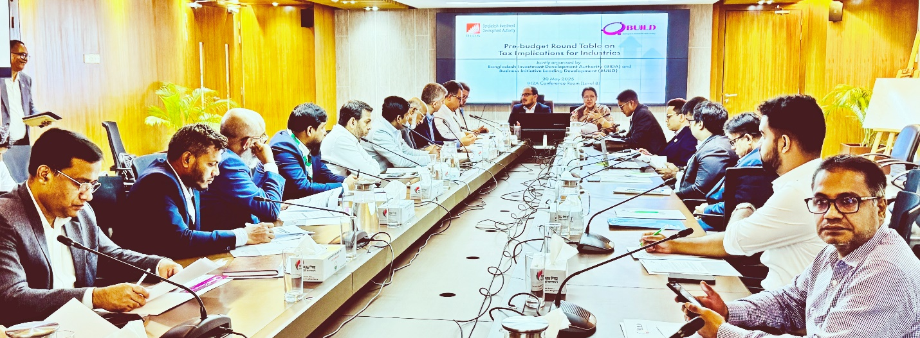
Caption: “Income tax provision on minimum tax translated into indirect tax whether a business makes a loss” — a public-private stakeholder roundtable discussion organized by BIDA and BUILD on Tuesday, 20th May 2025.
The meeting was presided over by Mr. Shah Mohammad Mahboob, Executive Member, BIDA (center left), and Ms. Ferdaus Ara Begum, CEO, BUILD (center right), with participation from representatives of local and foreign industries & specially members of the Beverage Manufacturing Association.

……….. X…………..

